**Lab 3**

9 December 2024

Authors: C1C Lino De Ros & C1C Connor Emmons



Professor: Dr. Brown

Engr 443 T2

**Documentation:** Used course notes and previous lab reports for formatting purposes. No unauthorized resources used. ChatGPT prompt can be found at

**Objective**

The objective of this lab is to design and evaluate a continuous time Kalman Filter to estimate a satellite’s pitch angle relative to the local horizon.

**Approach**

A generic FalconSat has been launched and stabilized using a gravity gradient boom, although there are still pitch oscillations that have not been removed yet. A horizon sensor on the satellite allows us to measure the pitch angle θ but the sensor is very noisy and doesn’t give individual measurements that are accurate enough for the control system on board. In order to determine accurate pitch angle states, a Kalman Filter is designed that incorporates those measurements real time and does a “best fit” to give a better estimate of the current pitch angle. To do this, the following steps are implemented.

1. A Simulink model to implement a Kalman Filter to estimate the pitch angle at each point in time is developed. To do this, an optimal observer is created using the gravity gradient state space equation.

2. A simulation using an initial value for Q of all zeros is run where the Kalman Filter output is compared to the raw measurements on the same plot. Additionally, the covariance matrix values are plotted.

3. A simulation using the Q matrix is run and the same plots in Task 2 are created.

4. A simulation using a unique “tuning” Q matrix is run to minimize uncertainty while maintaining accuracy is run, and the same plots in Task 2 are created.

**Assumptions**

The gravity gradient state space system is assumed to be uncoupled (i.e., the inputs do not directly affect the outputs without affecting the states). It is also assumed in our Simulink model that the satellite oscillates according to the gravity gradient pitch model given in equation 5. Finally, we assume that there are unmodeled perturbing forces in the real satellite from which the modeling and measurement errors are derived.

**Mathematical Techniques**

**Task 1:**

A continuous Kalman Filter that estimates satellite pitch angle is implemented in Simulink. The model is given in state space where:

(1)

(2)

where

– modeling errors

– measurement errors

Once the Kalman Filter is implemented, the optimal observer model becomes:

 (3)

 (4)

(5)

where





Next, the gravity gradient pitch equation is implemented into state space where the gravity gradient pitch equation is:

(6)

where

 - pitch angle

 - mean motion

 - moment of inertia about the roll axis

 - moment of inertia about the yaw axis

 - moment of inertia about the pitch axis

To implement this pitch equation in state space, the states are selected to be from which the following state space model is derived:

(7)

(8)

where

therefore,

Using the state space model in equation 6, a continuous time Kalman filter Simulink model is created to estimate satellite pitch states using the following constants from the FalconSAT satellite:

Moments of Inertia

*Ir* = 67.40 kg m2

*Ip* = 67.45 kg m2

*Iy* = 1.31 kg m2

Orbit Characteristics

alt = 560 km

inclination = 0º

eccentricity = 0

Horizon Sensor Data

Measurement standard deviation = 5º

The Simulink model is shown in Appendix A.

**Task 2:**

A simulation using the Simulink model developed in Task 1 and the following initial value of the Q matrix is run:

(9)

**Task 3:**

A simulation using the Simulink model developed in Task 1 and the following initial value of the Q matrix is run:

(10)

**Task 4:**

A simulation using the Simulink model developed in Task 1 and the following initial value of the Q matrix is run:

(11)

**Theoretical Predictions**

The continuous time Kalman filter is an algorithm used to estimate the state of a system evolving over time with linear dynamics and noisy measurements. It operates continuously, integrating these two stages in real-time to provide an updated state estimate at every moment. The filter operates in two main stages: prediction and correction. During the prediction stage, it uses the system's dynamics to forecast the state and its uncertainty based on prior information. This involves propagating the state estimate forward in time and accounting for the system's inherent process noise, which reflects uncertainties in the model. This step utilizes the following equations:

|  |  |
| --- | --- |
|  |  |

where is the state transition matrix , is the state, and is the covariance matrix.

When a new measurement becomes available, the correction stage updates the state estimate and reduces its uncertainty. The filter calculates a quantity called the Kalman gain, which determines how much weight to assign to the new measurement relative to the prediction. It then uses this gain to correct the predicted state with the measurement, while also adjusting the associated uncertainty to reflect the improved estimate. The correction stage utilizes the following equations:

|  |  |  |
| --- | --- | --- |
|  |  |  |

where is a matrix of how uncertain a model is prescribed to be. In the case of this lab, it represents the standard deviation of the horizon sensor of the satellite which is calculated in Equation 5.

To find the and matrices, the given gravity gradient pitch equation is put into a state space model. Equations 6 and 7 show how these matrices are found.

**Experimental Results/Discussion**

Equations 9, 10, and 11 show the weighting matrix for Tasks 2, 3, and 4, respectively. In Task 2, the weighting matrix is the zero matrix. By doing this, we assume that our model has no uncertainty and becomes “smug”. This model is very confident, as seen in the lack of residuals, but significantly deviates from the measurement data as time increases as seen in Figure 1.

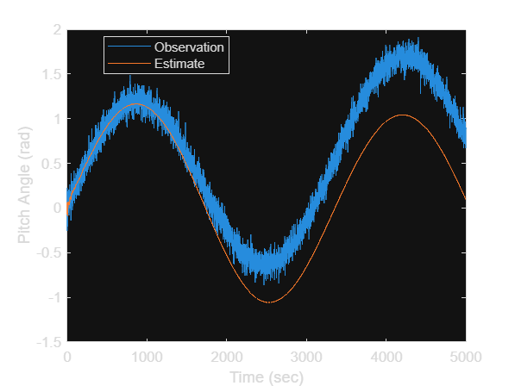

Figure 1. Observation and Estimate of Pitch Angle vs. Time for Q as the Zero Matrix

The covariance decreases quickly, which also supports the hypothesis that this model is “smug”. The components of the covariance matrix are shown in Figure 2.

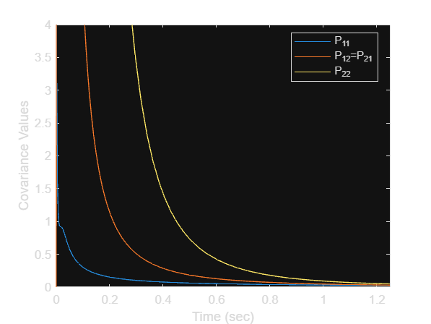

Figure 2. Covariance Values vs. Time for the Zero Matrix

In Task 3, the weighting matrix is the identity matrix. This model is not very confident at all leading to large residuals that cover every possible state of the measurement data. This model, however, closely follows the measurement data for all time values analyzed. This model compared to the observed data is shown below in Figure 3.

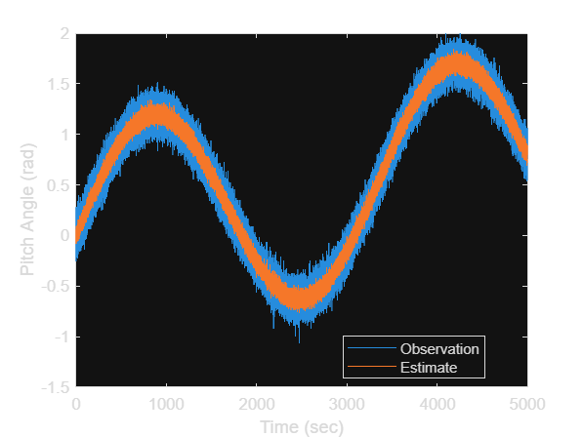

Figure 3. Observation and Estimate of Pitch Angle vs. Time for Q as the Identity Matrix

The problem with having a filter this uncertain is that is leads to overfitting the data. Zooming in on a portion of this graph displays this overfitting behavior, as seen in Figure 4.

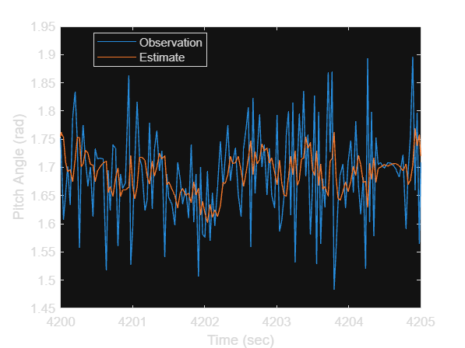

Figure 4. Observation and Estimate of Pitch Angle vs. Time for Q as the Identity Matrix, Zoomed In

Notice how the estimate follows the noise in the data. This is still an inaccurate model even though the residuals are very low because the estimation does not capture the true pattern of the data, and mostly captures the noise. Unsurprisingly, the covariance values remain large compared to the “smug” model due to this model’s lack of confidence. These are displayed in Figure 5.

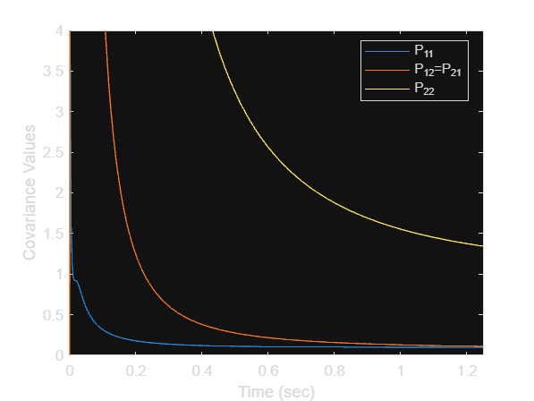

Figure 5. Covariance Values vs. Time for the Identity Matrix

Finally, Task 4 allows us to generate our own matrix. This model is designed to be very confident with tiny residuals while still closely following the measurement data at all times. This model incorporates the small residuals seen in Task 2 while not becoming “smug” and tracking the measurement data seen in Task 3. The values of the weighting matrix are chosen experimentally to achieve the best possible model. Plotting the model’s estimate over the data reveals that the model successfully captures the pattern of the data without overfitting to the noise as shown in Figure 6.

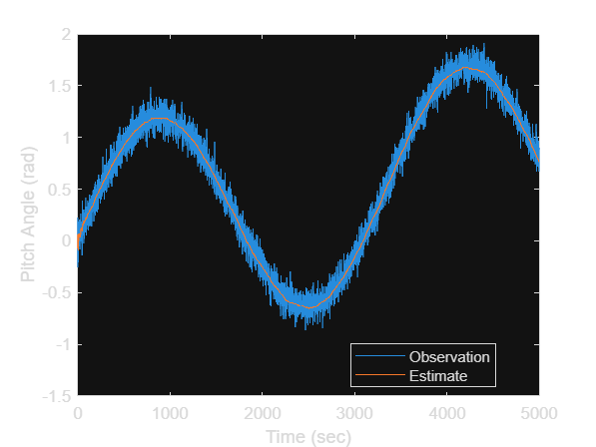

Figure 6. Observation and Estimate of Pitch Angle vs. Time for Optimal Q

Notice how the model follows the data, but not so closely that it is thrown off by the noise like the previous example. The covariance values do not decrease nearly as quickly as the “smug” model, but decrease much faster than the unconfident model. These are shown in Figure 7.



Figure 7. Covariance Values vs. Time for the Optimal Matrix

**Conclusions and Recommendations**

This lab highlighted the critical role of Kalman Filters in improving the accuracy of state estimation for dynamic systems like satellites. By leveraging noisy horizon sensor data, the continuous-time Kalman Filter was able to provide a refined estimate of the satellite’s pitch angle relative to the local horizon. This iterative filtering process integrates system dynamics with real-time measurements to minimize uncertainty, demonstrating its effectiveness in handling noisy and incomplete data.

The experiments showed that the choice of the process noise covariance matrix QQQ significantly influences filter performance. The "smug" model (Q=0Q = 0Q=0) underestimated measurement uncertainty, leading to divergence from true states. Conversely, the unconfident model (Q=IQ = IQ=I) overreacted to noisy measurements, resulting in overfitting. The optimal filter achieved a balance by minimizing residuals while capturing the true data trends without excessive sensitivity to noise.

The Kalman Filter's dual-stage process of prediction and correction proved vital in this context. During prediction, the filter used the satellite's gravity-gradient dynamics to forecast pitch states, while the correction step integrated new sensor data to refine these predictions. This synergy allowed the filter to adapt dynamically, improving state estimates over time.

Future work could explore the application of adaptive Kalman Filters, which adjust the QQQ matrix dynamically based on real-time noise characteristics. Expanding the model to incorporate additional perturbing forces or non-linearities in satellite dynamics could further enhance its robustness. Applying this optimized Kalman Filter to real-world satellite data would provide practical validation and deeper insights into its operational effectiveness.

Appendix A: Simulink Model

Appendix B: MATLAB Code